**Fila ray low sneakers for fashionable girls**

**When Fila ray low sneakers are a shoes for You? Check in our article. We also suggest how to wear them this season, be sure to read!**

**Sneakers - the most popular shoes in summer season**

Snickers are the most fashionable shoes in the summer season, you probably do not need to tell anyone about it, or especially prove it. Sport shoes are combined with short, high-waisted shorts, airy dresses, skirts, especially those with a satin finish. We also wear these shoes with popular leggings before the knee. Importantly, let's choose a model that, not only in summer, can be easily combined with fashionable clothes. [Fila ray low sneakers](https://sneakerstudio.com/product-eng-17081-Womens-shoes-sneakers-Fila-Ray-Low-1010562-150.html) are sports shoes that will also be part of fashionable stylizations in the fall, straight from the insagrama.

**Fila ray low sneakers - These 90 years have returned!**

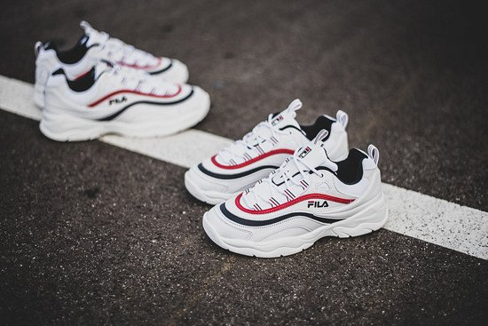

FILA is a brand that has once again gained amazing popularity among teenagers and not only. The model **fila ray low sneakers** are white sports shoes, stylized to those from the 90s. They have a black and red finish and are also signed with a Fila brand mark - everyone will know that you have fashionable shoes! This is one of those models that I am definitely very popular on Instagram and other Social media. So if you want to look like the hottest girls in this season, you should consider choosing a Fila model