**Adidas Originals Continental 80 BD7645 - what to wear them for?**

**Do you like the model Adidas Originals Continental 80 BD7645? You are wondering what you can wear them for**

**? In our article, we give a few suggestions.**

**Adidas shoes and clothes**

Clothes in 2019 are inspired by the fashion from the 90's and 80's, therefore a very fashionable sports outfit. Therefore, on the streets of the most fashionable cities such as Milan New York or London, we notice a lot of people who decide to put on a pair of sports trousers, such as a tracksuit with an interesting t-shirt with a colored print, a Ramon or a sports sweatshirt and Snickers. Adidas is a leading brand that is incredibly fashionable this season because of its characteristic Three stripes. We will notice them not only on clothes but also on shoes. **Adidas Originals Continental 80 BD7645** is a model of shoes inspired by the 80's and which perfectly matches the canon of contemporary fashion

**Adidas Originals Continental 80 BD7645 - how to wear them**

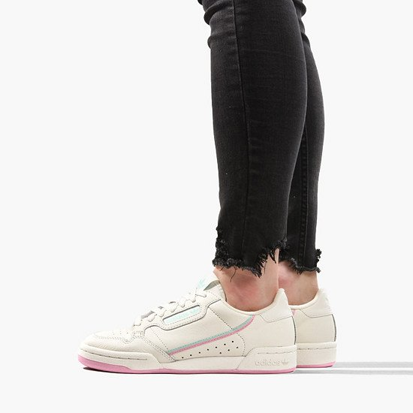

[Adidas Originals Continental 80 BD7645](https://sneakerstudio.com/product-eng-21369-adidas-Originals-Continental-80-BD7645.html) are shoes made of high quality natural leather in beige. In addition, the sole of shoes and individual details are made in the color of powder pink, very fashionable colors this season. Shoes can be left with both jeans and a long-sleeved shirt. You can also wear them in a one-color dress, for example gray or pink and white. They will also look great for navy, black, pink or cream skirt.