**The north face clothing mens - best for winter**

**In the online store sneaker studio you will find a wide selection of winter clothing and among them the north face clothing mens as well as a wide selection of women's assortment.**

**Winter clothes at Sneaker Studio**

If you are a fan of winter activities such as skiing, snowboarding or cross-country skiing, or you simply like mountain climbing, ice skating or long mountain walking, you certainly know how important it is to wear proper clothing that will ensure your comfort and keep you warm body. One of the most popular brands on the international market that create high-quality sportswear for women and men is the north face company, which has recently enjoyed great popularity. [The north face clothing mens](https://sneakerstudio.com/eng_m_Brands_The-North-Face-1889.html) and womens can be found in the concept store Snekaer Studio. Let's check what to look for.

**The north face clothing mens**

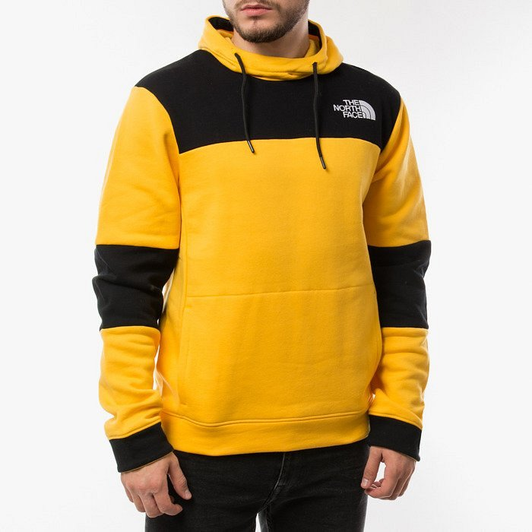

If you plan to spend a lot of time outdoors in the cold months, your body will definitely need adequate protection. In sneaker Studio you will find thick, winter sweatshirts from the renowned company The North Face but at the same time fleece as well as jackets and all kinds of blouses with short and long sleeves or sports backpacks. **The north face clothing mens** and womans offers high quality clothes that have a reputation due to their durability and high-class materials from which clothes and accessories are sewn.