New balance ms574pcb - stylish, retro shoes
Why is the New balance ms574pcb one of the trendiest models of sports shoes for men? Read in our article and check what's the mode this season.

Fashion for retro style

The street of the most fashionable cities like London, New York or Milan or Paris is boldly returning retro style. The characteristic clothing for the retro trend is mom's jeans, high-waisted jeans on the model of the cult Levis 501 pants. Both fanatics and fashion fans wear daddy's shoes. What is it? These are sports shoes, called sneakers, in this case modeled on models from the 90s. Cult models are those produced by the brand Fila and new balance ms574pcb. Retro style is also the love of leather ramonesek and denim jackets. Fashionable are satin, patterned hair ornaments, straight from the Madonnny music videos and leggings in front of the knee - an absolute hit for just 90 years.
New balance ms574pcb - for fashionables mens

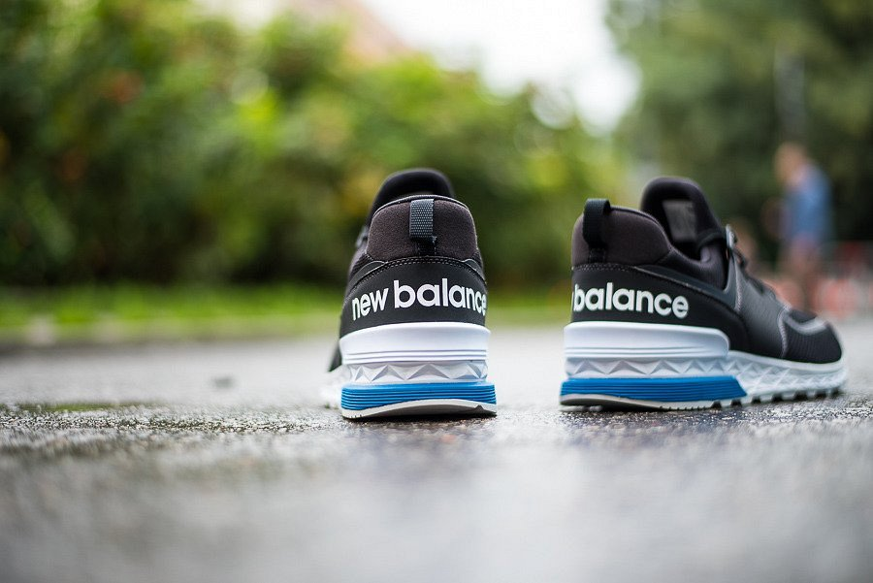
If you are one of those people who pay special attention to fashion and creating your image, certainly the above-mentioned new balance ms574pcb model will work in your case. . Shoes designed in 1988 as shoes for running, are currently equipped with ENCAP® shock absorption system, making them perfect for everyday use.

