Edwin men's clothing - hit in the fashion industry!
Who is behind the fashionable Edwin brand and why is it so popular in the United States and beyond? Check out our article!

Edwin - Japanese aesthetics

Interest in Brands from countries with an exotic culture such as Japan, Korea or Scandinavia or Canada is very fashionable recently! Looking for our own style and uniqueness in creating everyday and special creations, we are also looking for perfect materials and simple forms. Thanks to them we will look stylish but also classy. And this is the Edwin brand, which was founded in 1947 in Japan. It was founded by K.K. Tsunemi. Currently, it is best known for the production of edwin men's clothing and extraordinary jeans, but Edwin also offers other interesting products. What kind of?
Edwin men's clothing - what is worth having from them?

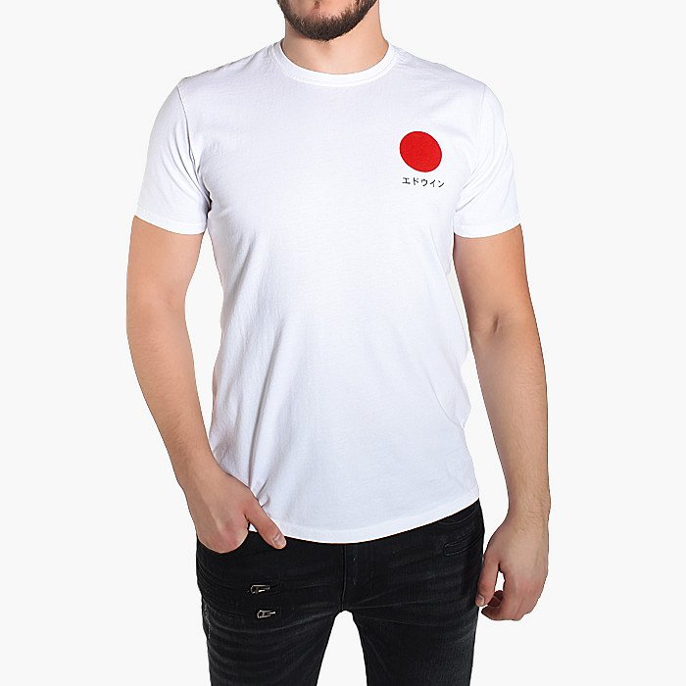
An absolutely iconic edwin men's clothing product are denim pants that are worn by Hollywood stars of huge caliber, like Brad Pitt! Edwin also offers interesting t-shirts that refer to Japanese culture. They are therefore minimalist although incredibly stylish. On many of them, just like on sweatshirts, there are pronty of the Japanese flag or the Japanese alphabet!

