Reebok workout plus 1987 vintage
Reebok workout plus 1987 vintage - iconic shoes for men about which we write this article because they perfectly fit canon trends for fall.

Workout shoes, that you can wear on a daily basis

With the advent of autumn, a new season has also come into the world of fashion and with it we can see the latest fashion trends, which will apply until spring. The fashion weeks in the most important European capitals and not only presented proposals of top designers for autumn 2019 and 2020, based on this we know what can be counted among the top trends of this season. You can certainly see a return to the 50s, 60s and 70s. Vintage items and especially accessories such as belts or shoes as well as textures and patterns are something worth paying attention to when composing a wardrobe in the fall. If your wardrobe lacks sports shoes, so-called sneakers for fall, focus on models, that have been produced by top brands for many years. One of these models are reebok workout plus 1987 vintage shoes, which were designed in 1984.
Reebok workout plus 1987 vintage

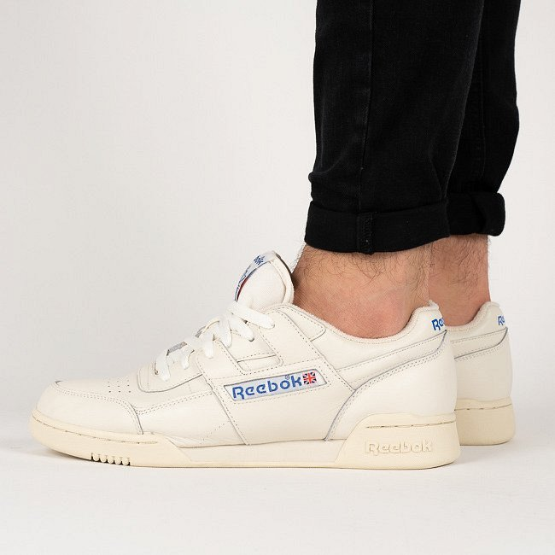
These are sports shoes that were made in the 1980s and also present design. Reebok workout plus 1987 vintage were created from very delicate skin and thus will be perfect both during training and in everyday use. Thanks to the beige color, you can easily combine these shoes with autumn clothes

