HUF Men's Clothing in the Sneaker Studio catalog
HUF Men's Clothing is available in the online store and Sneakerstudio stationary. Is it worth buying them?

Premium clothes for men at Sneaker Studio

Sneaker Studio is a store that in stationary form operates in Krakow, Poland. In addition, it also runs an online store, in which we find a wide selection of both footwear and clothing for women and men. Sneaker Studio focuses on street wear clothing that is hard to find on the international market. Therefore, we specialize in offering Premium Brands and their products, and HUF Men's Clothing is the best example.
HUF Men's Clothing

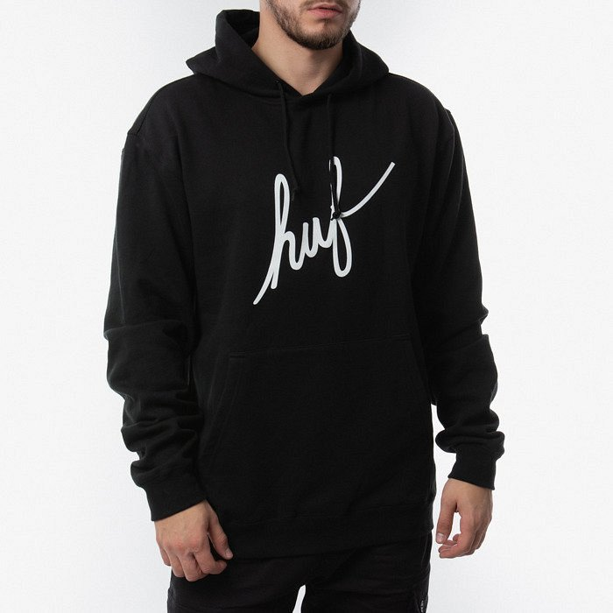
The huf brand was created in the 1980s by a skateboarder popular in New York. Therefore, HUF refers to a sport lifestyle, offering HUF Men's Clothing like sweatshirts, t-shirts and all kinds of designer accessories such as socks. All these products are available in the concept store catalog of the sneaker studio. It is a street wear brand that has been enjoying unchanging popularity among young people since 1980! Therefore, these clothes will prove themselves in everyday use for those of you who value comfort and fashion at the same time.

