Neon shoes - fashion not only for autumn
Did you know that in the fashion world, the fashion for neon shoes has come again to the salons? Are you wondering whether these types of shoes are also fashionable in our everyday life?

Sneaker Studio - shoes and not only

Interestingly, sneaker studio is the brand that created the Concept Store in Krakow. In order for our products, both sports shoes and clothing, to be available to all people throughout Europe, we also decided to create an online store where you will find not only unique models of sports shoes, but also other accessories for every fashion fan. In this way, we have become one of the fashion media not only stationary, in Poland, in Krakow, but also on the Internet - where we reach fashion lovers around the world! Are we somewhat specialists in fashion also think that neon shoes are an absolute fashion hit?

Neon shoes - are they fashionable?

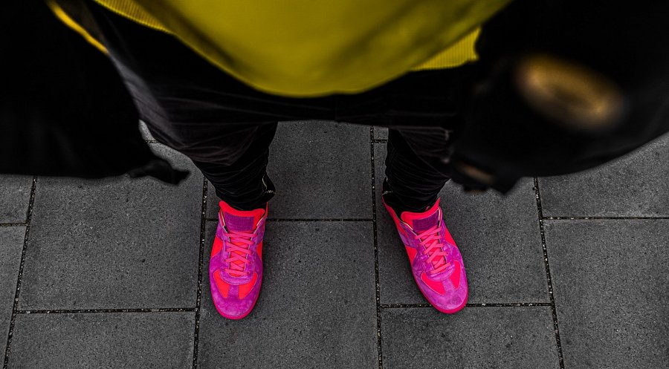
Many of us associate the fashion with neon shades with the 90s. And very good, because it was then that all kinds of neon colors appeared not only on TV but also on the streets, not only large cities but also smaller towns. Neon shoes at that time were an absolute hit, they were left with an equally colorful outfit. Now, however, we focus on a combination of neon accessories such as shoes, belts, cufflinks and handbags with slightly more calm stylizations in basic colors, although of course you can also find people who are quite strongly modeled on the colorful stylizations of the 90s.

