Arkk copenhagen shoes
In our article, we write something about arkk copenhagen shoes. If you like to know more about fashion, read it!

Streetwear shoes

Do you know the Arkk Copenhagen brand? If not, there is definitely time for you to meet her! It is one of the hottest footwear brands for the autumn and winter season of 2020. These are sports shoes, that combine streetwear fashion with Nordic aesthetics. The brand was founded in 2014 and has been increasingly popular around the world since then. Before the new model goes on sale, the brand tests it for 18 months - to bring it to perfection. Arkk copenhagen shoes is something for fans of style, durability, design and minimalistic forms.

Arkk copenhagen shoes

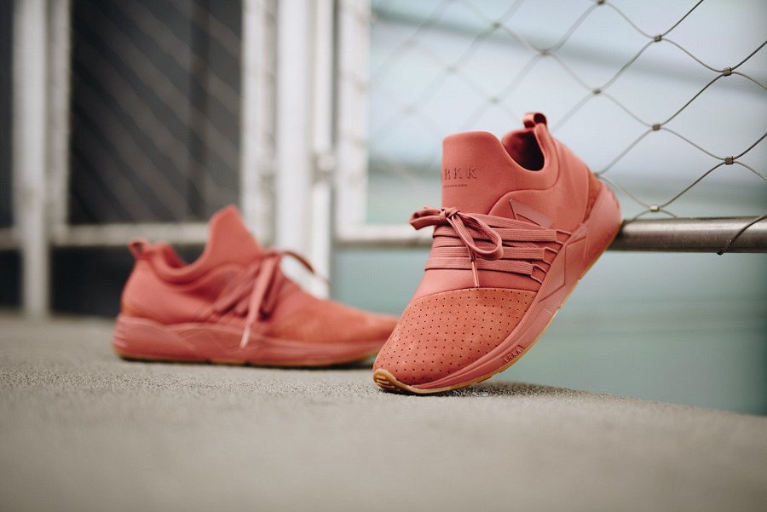
The brand focuses on creating sports shoes, however universal and simple. Thanks to this, the design of both sports shoes for women and men matches many styles. In addition, the brand is obsessed with innovation. Arkk copenhagen shoes are not only fashionable, they are the culmination of convenience and comfort, which is why your foot will feel perfectly all day long. Because this is important for the residents of Copenhagen - everyday comfort of use and convenience.

