Dr martens 1925 sex pistols - limited edition
Martensy is one of the timeless brands that practically never goes out of fashion. Model Dr martens 1925 sex pistols is one of the limited edition, available in our offer.

Fashion for martens
Since the top models and instagram stars started publishing their photos and live coverage in flimsy dresses with flowery princes or in coarse or other patterns, and with martens on their feet, the craze for the Martens shoe model has returned again. Both the model above the ankle and before are extremely popular. Women's models are combined with midi dresses in a retro style inspired by the Paris look and also with bells jeans, 7/8 length. The model in front of the ankle is more often chosen by men. It looks great with both washed jeans, preferably in classic versions with a slightly higher state. They will look great with tight pants or typi stylized for suit. Which male model is sipping popularity records? Dr. Martens 1925 sex pistols!
Dr martens 1925 sex pistols - something for man

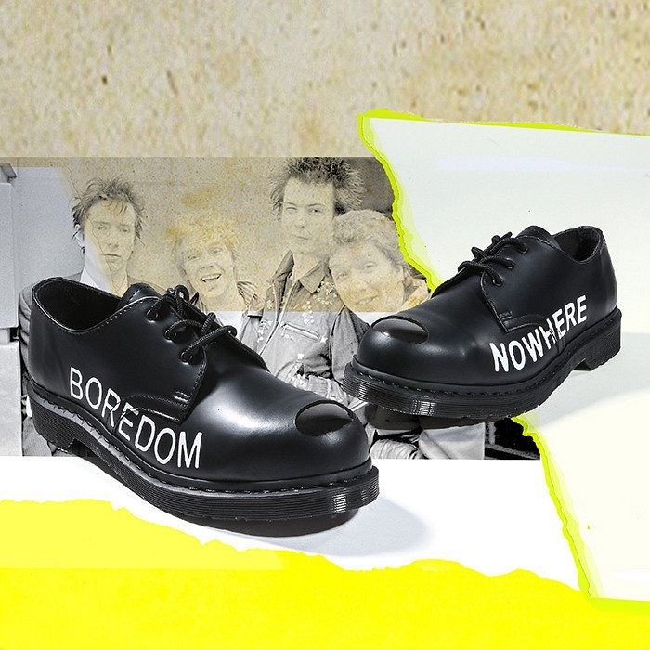
If you are looking for shoes that are not only incredibly popular and fashionable but you also want it to be a well-made model that will last you longer than one season, choose a martens company. Model dr martens 1925 sex pistols and many more are solidly made footwear that is known around the world for its excellent quality.

