Fila venom italy pack - best for spring and summer
Fila venom italy pack - sports shoes of a reputable brand that is breaking records in the world of fashion and the web. Check why it is worth choosing this model.

Fila - one of the most popular brands 2019
2019 in fashion brought us back to the 90s. The most fashionable trends are based on inspirations from that time. The best example of this is sports shoes, which are stylized on retro shoes from the 90s, which everyone wears! Large sneakers appear on offer for the spring / summer season of each brand, and the incredibly popular Fila brand introduced several models maintained in such a climate. What counts is not only the shape of sneakers but also the appropriate combination of colors. The most fashionable ones combine several shades with one strong color option, just like the fila venom italy pack.
Fila venom italy pack for man

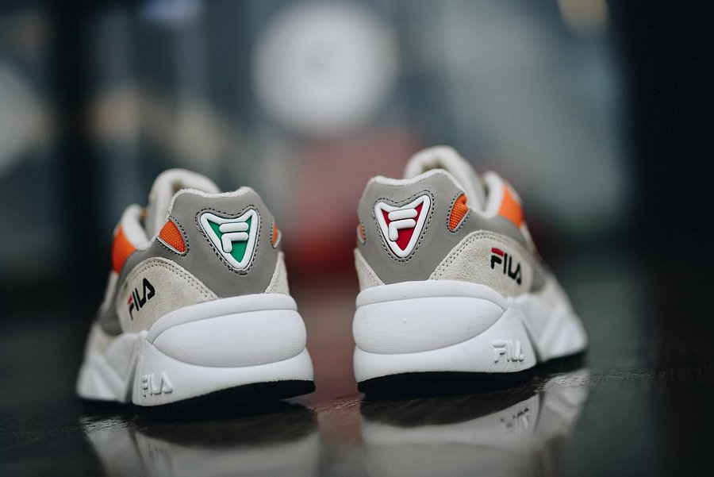
Fila is definitely looking for a retro atmosphere in his new collection for 2019. we find in it not only large, oversize sweatshirts and t-shirts, but also tracksuits with logos, deceptively similar to those that we will see on music videos from the 90s. Sports sneakers like the model fila venom italy pack is a combination of a fresh look at sports footwear with retro shape . Do you like such atmosphere? In Sneaker Studio offer you will surely find a dozen or so models for yourself!

