Puma x Cali - because white shoes are fashionable
Did you know that white shoes are the most fashionable this summer season? Our proposal for women is Puma x Cali, check why.

Fashion for sports shoes
Sports footwear for many seasons is one of the most popular models of shoes. Snickers reign on the streets of the world fashion capital such as New York, London or Milan or Paris. We wear them with 90s stylized jeans, airy polka-dot dresses or flowers, with satin skirts or such that are made of silk. Sport shoes also look great in leggings, this season the most fashionable ones are those reaching before the knee. One of the top trends in sports footwear is the worship for massive shoes in a shade of white or beige. Puma x Cali fits perfectly into this canon
Puma x Cali - interesting combination of colors

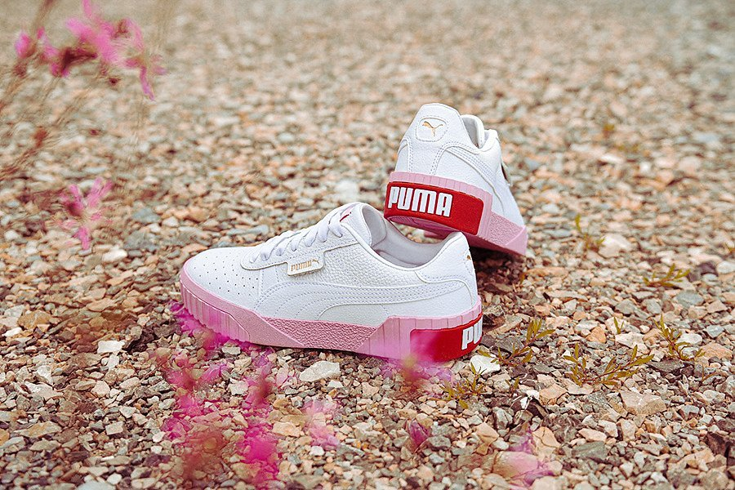
If you are looking for a custom model that will be fashionable at the same time, Puma x Cali seems to be the best choice. These are massive sports shoes in white. However, they stand out against other white shoes because their sole is powder pink with the addition of a Puma red mark. The whole creates an incredibly fashionable combination that can be easily adapted to fashionable clothes in spring and summer

