Reebok Pyro OG 1993 DV4849 - designer shoes for men
If you are looking for designer shoes for yourself, or for your boyfriend, we encourage you to familiarize yourself with the Reebok Pyro OG 1993 DV4849 model, about which we write a bit more in the article.

Reebok and his design for 2019
2019 is a return to the roots, many brands focus on Design related or inspired by the 80's and also the 90's. Fashion is coming around so nobody should be surprised that just this year it will tell the designers decided to model themselves on the future. Also renowned brand Reebok decided to inspire dusk and sometimes That's why in projects and collections presented for 2019, we can see things kept in retro style with the addition of details in bright colors like green, yellow or pink. A perfect example is the Reebok Pyro OG 1993 DV4849.
Reebok Pyro OG 1993 DV4849 - an interesting variation for the summer

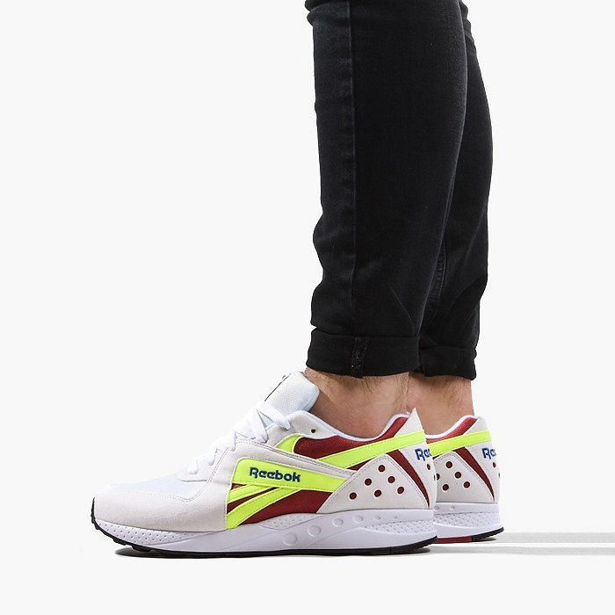
The summer season, in fashion, is always associated with amazing colors. Neon lights are an absolute hit this season. Reebok Pyro OG 1993 DV4849 are white shoes whose details are made in neon color, in this case it is yellow. This is a model that will certainly work for people who like to stand out from the crowd and put together interesting accessories, like footwear with minimalist clothes.

