Adidas x_plr cq2405 - for a gym and everyday life
Do you need shoes that will work well both for jeans and those where you can comfortably go sightseeing during the holidays and also go to the gym? We recommend adidas x_plr cq2405.

Adidas and other popular brands
With classic models of shoes is just like with well-chosen jeans - they will never get bored and if we find a model that suits us there is a good chance that we will buy it over and over again. For many what counts is not only good performance or color but also a brand because, for example, they love things signed with a Nike or New Balance or Puma or Adidas stamp. We can stay for a moment with the last brand. Due to the fact that its popularity has recently risen steadily, especially in Europe. This is related to the return to the retro style, where the classic Adidas tracksuit signed with characteristic three stripes was an absolutely iconic thing that everyone wanted to have. The footwear model adidas x_plr cq2405 is a reference to the sporty style and fashionable running shoes of this brand.
Adidas x_plr cq2405 - men sport shoes

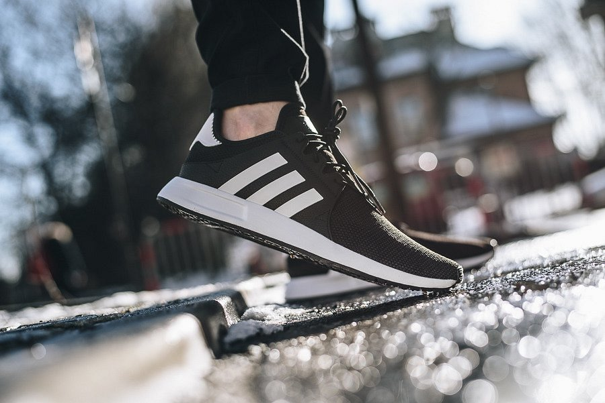
Shoes that have been produced since 2016 and are one of the most popular models of the Adidas brand. They resemble running shoes not only with design but also with their comfort. In addition, they are very light and allow air to pass through. The adidas x_plr cq2405 model is suitable for both gyms and other sports activities as well as for everyday use.

