Puma alteration kurve - orginal model for men
Are you looking for the original model of sports shoes not only for the summer? Below we present one of our offers Puma alteration kurve.

Puma and new design
Fashion has changed its dimension quite strongly this year. Especially in the field of additives. Patterned cowboy boots from the wild west are fashionable and shapely sneakers with streamlined shapes and minimalist colors have been replaced by streetwear sneakers totally colorful, with oval shapes, reminiscent of top models of companies such as nike or fila of the 80s and 90s. Interestingly, a company that presents an unbelievably attractive collection for 2019 is Puma. Such models as puma alteration kurve, win the hearts of streetwear fans all over the world!

Puma alteration kurve for fashionable men

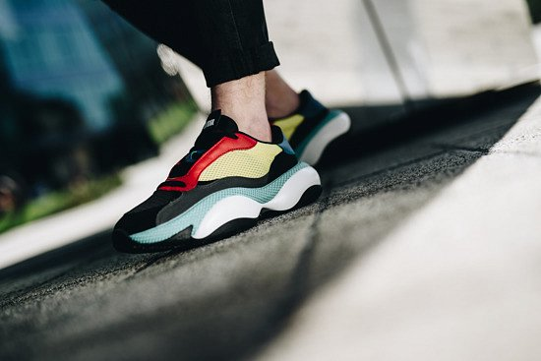
If you are a man for whom footwear is an important part of clothing, you are not afraid of colors and the original design is your second name - the above-mentioned clumsy sports shoes puma alteration kurve.
This footwear that attracts attention with original design, surprises with irreplaceable comfort and makes it difficult to take them off the legs. These are massive sneakers and at the same time futuristic design. Inspired by a post-apocalyptic world.

