Champion hoodies and others champion products
Why do we think champion hoodies are so popular on the international market? The answer to this question can be found in the article. Welcome!

Champion, Fila and other fashionable brands

Undoubtedly, it can be seen that the fall-winter fashion is still reminiscent of the 90s. Colors such as red and navy blue, white and gray are absolute hits, especially in youth fashion and streetwear. One of the brands that is definitely in the top 5 is the Champion brand, right next to brands such as Fila or Ellesse or Superdry or Adidas. Champion hoodies for women and men are a popular purchase for many people, not only under 20 years of age. Why?

Champion hoodies

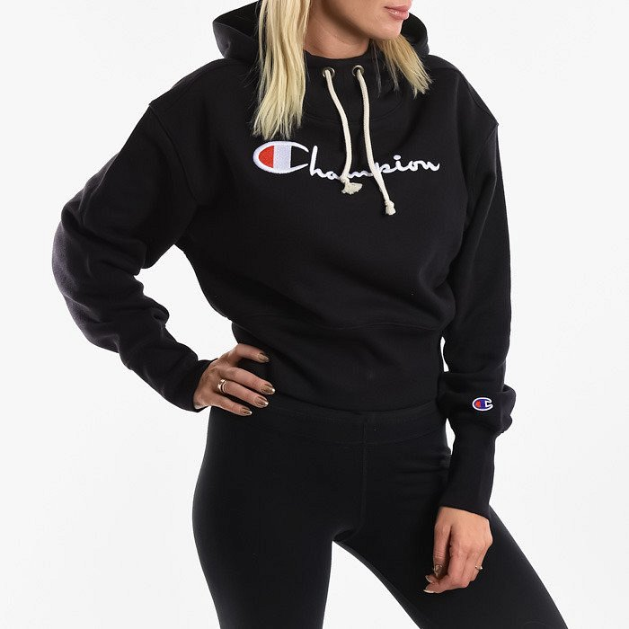
Champion clothes are very minimalistic and use basic colors. This makes them suitable for virtually anyone! Champion hoodies are the perfect choice for fall and winter because we can combine them with jeans, a skirt, sports pants, leggings or suit pants to create original outfits. In addition, the sweatshirts are very warm and of good quality! We should also remember that sweatshirts or other Champion brand products are signed with the company logo, which perfectly refers to the 90s. So it fits in with the trends for 2020!

