Sorel women's hiking boots - winter option
When looking for winter boots, consider sorel women's hiking boots. Why? Check in the article.

Women's winter shoes

The offer of winter footwear for women is very wide. You can choose both boots and boots both on a flat sole and high heels as well as insulated sports shoes. Depending on what physical activities we carry out and where we work such a model shoes, we usually choose winter and autumn season. There is no doubt, however, that these shoes must be of good quality and stand out with their resistance to low temperatures. Sorel women's hiking boots is a model of winter footwear for women who above all value comfort and convenience. Will they be the right choice for the winter?
Sorel women's hiking boots

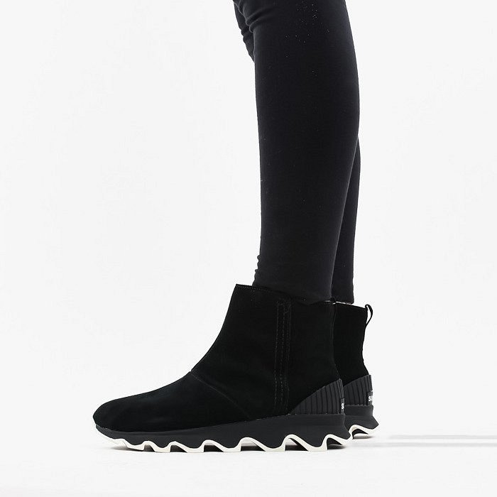
Sorel women's hiking boots are footwear that is insulated, therefore it can certainly be our choice when we live in a place where there are low temperatures in winter and autumn. This footwear will work both in everyday use and in the case of any physical activities. In the Sneaker Studio online store you will find a wide selection of Sorel products in many colors, so that each of us can find the right model for themselves.

